Week 6
Module 10

Prb6:

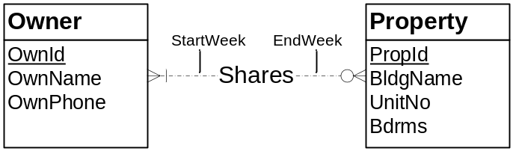

Owner (OwnId, OwnName, OwnPhone)

Property (PropId, BldgName, UnitNo, Bdrms)

Shares (OwnId, PropId, StartWeek, EndWeek)
FOREIGN KEY (OwnId) REFERENCES Owner
FOREIGN KEY (PropId) REFERENCES Property

